**PERSONAL ASSISTANCE FOR SENIORS WHO ARE SELF-RELIANT**

# FINAL REPORT

**PROJECT TEAM ID : PNT2022TMID38529**

**TEAM MEMBERS : R.ABIRAMI ( TEAM LEADER )**

**S.ABINAYA**

**M.P.MUTHARPAAVAI**

**A.ANUSHYA**

# CHAPTER 1 INTRODUCTION

## 1.1 PROJECT OVERVIEW

The Project concentrates on creating a medicine reminder application.

MedicineReminder Project is a native android application meant to aid forgetful and busy senior citizens by reminding them to take their daily medications. It is designed for users who need a little help keeping track of their medication schedule and who are dedicated to keeping the schedule but forget things easily. The application allows the user to store pill objects and multiple alarms for those pills at the correct times.

## 1.2 PURPOSE

The objectives of this project are to develop a prototype of a smart medicine reminder for elderly people that helps them consume the medicines right on time.

In recent times, the rate of consumption of medicines has highly increased due to the wide spreading of di erent diseases and illnesses across the globe. While some diseases are temporary, many diseases have a toll on human health for a lifetime. In the pursuit of maintaining a healthy lifestyle, we often nd ourselves to be sick. This could be threatening if not properly treated.

A visit to the doctor and consumption of the medical prescription becomes a necessity. Nevertheless failing to consume the medicine regularly could cause a lot of problems. Keeping in mind this problem, the idea of creating a smart device that alerts the patient to take medicines right on time, so that they would recover soon and stay healthy without any issues in the body.

# CHAPTER 2 LITERATURE SURVEY

## 2.1 EXISTING PROBLEM

The existing methodologies that provide solutions for the speci ed problem include various gadgets available to assist patients in taking their medication either by simplifying administration or by assisting them in remembering to do so. Pill reminder charts, drug diaries, calendar clocks, telephone prompting services, multi-compartment compliance aids (MCAs), talking labels, voice reminders, watch reminders, daily pill boxes, and automated pill dispensers are just a few examples.

## 2.2. REFERENCES

1.A. Sawand, S. Djahel, Z. Zhang, and F. Na. Multidisciplinary Approaches to Achieving E cient and Trustworthy e HealthMonitoring Systems. Commun.China (ICCC), 2014 IEEE/CIC Int.Conf., pp. 187–192, 2014.

1. D. a. Clifton, D. Wong, L. Clifton, S. Wilson, R. Way, R. Pullinger, and L. Tarassenko. Alarge-scale clinical validation of an integrated monitoring system in the Emergency Department. IEEE J. Biomed. Heal. Informatics vol. 17, no. 4, pp. 835–842,2013.
2. M. Parida, H.-C.Yang, S.-W.Jheng, and C.-J. Kuo.Application of RFID Technology forIn-House Drug Management System.15thInt. Conf.Network-Based Inf. Syst., pp. 577–581, 2012.
3. L. Ilkko and J. Karppinen.UbiPILL A Medicine DoseController of Ubiquitous HomeEnvironment. 2009 Third Int. Conf.Mob. UbiquitousComput.Syst. Serv. Technol., pp.

329–333, 2009.

1. A. Kliem, M. Hovestadt, and O. Kao. Security and Communication Architecture forNetworked Medical Devices in mobility-Aware e-Health Environments,” 2012 IEEE First Int.

Conf.Mob. Serv., pp. 112–114, 2012.

1. S. T.-B. Hamida, E. Ben Hamida, B. Ahmed, and A. AbuDayya.Towards e cient and secure in-home wearable insomnia monitoring and diagnosis system.13th IEEE Int.

Conf.Bioinforma. Bioeng., pp. 1–6, 2013.

## 2.3 PROBLEM STATEMENT DEFINITION

Tracking the health of a person and proper medication improves their lifetime.

Studies suggest that most of the deaths of senior citizens occur during the night when the person is asleep. Sometimes elderly people forget to take their medicine at the correct time. They also forget which medicine they should take at that time. And it is di cult for doctors/caretakers to monitor the patients around the clock. This work proposes a personal assistant for the elderly or a patient. Personal assistants can provide in-home respite care, allowing family members or caretakers to take a temporary break.

# CHAPTER 3

**IDEATION AND PROPOSED SOLUTION**

## 3.1 EMPATHY MAP CANVAS

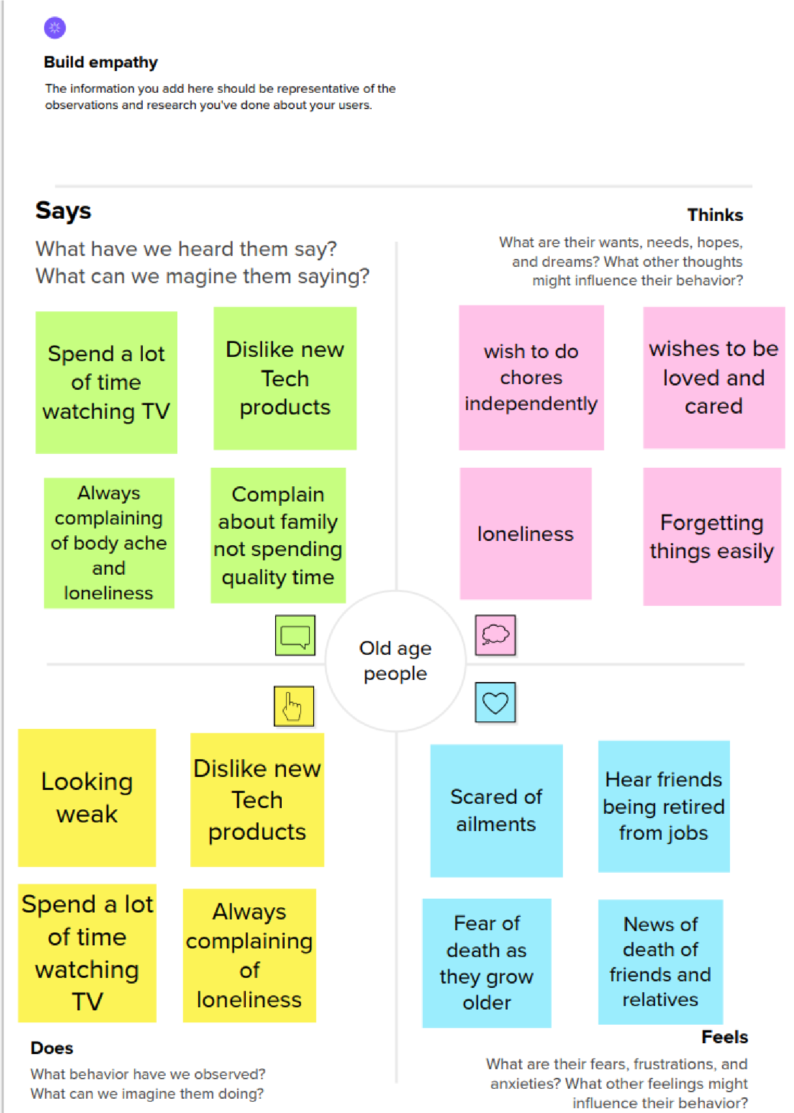

## 3.2 PROPOSED SOLUTION

|  |  |  |
| --- | --- | --- |
| **S.No.** | **Parameter** | **Description** |
| 1. | Problem Statement (Problem to be solved) | The major issue is that elders couldn't remember their medicine consumption due to memory loss and their busy schedules. |
| 2. | Idea / Solution description | Device is made to set reminders for medicine consumption and help people worry less about it. |
| 3. | Novelty / Uniqueness | Unique feature is that it has a voicing system that will act like a mentor for reminding us. |
| 4. | Social Impact / Customer Satisfaction | Customers will be satis ed with this device which will behave like a friend for helping us to do things at the correct time. |
| 5. | Business Model (Revenue Model) | Revenue for this product will be achieved up to our expectations as customer satisfaction suggests, it is been modeled to show up the revenue for the outcome. |
| 6. | Scalability of the Solution | This product can be scaled up to the level of customer satisfaction. |

## 3.3 PROPOSED SOLUTION FIT

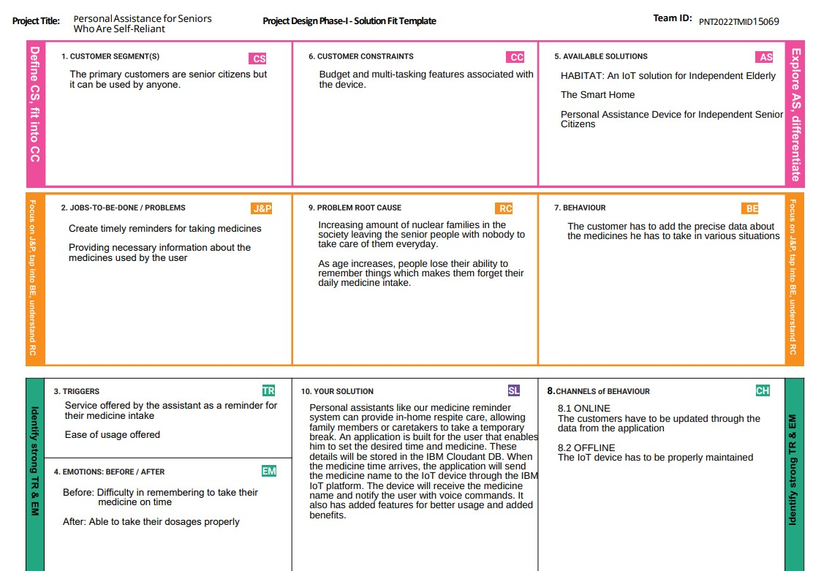

## 3.4 IDEATION AND BRAINSTORMING

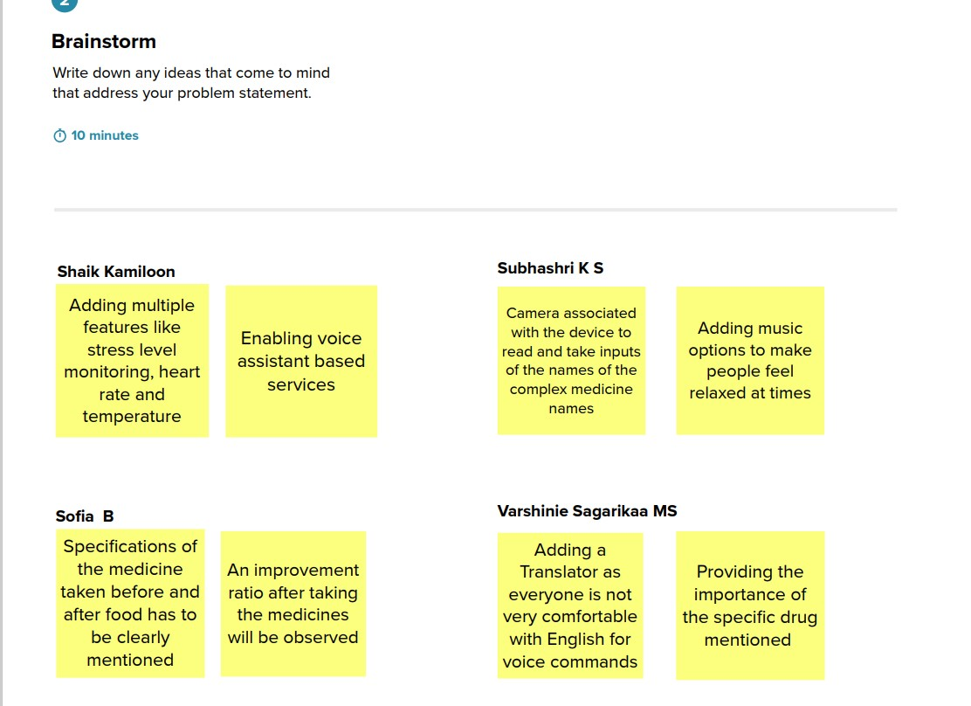

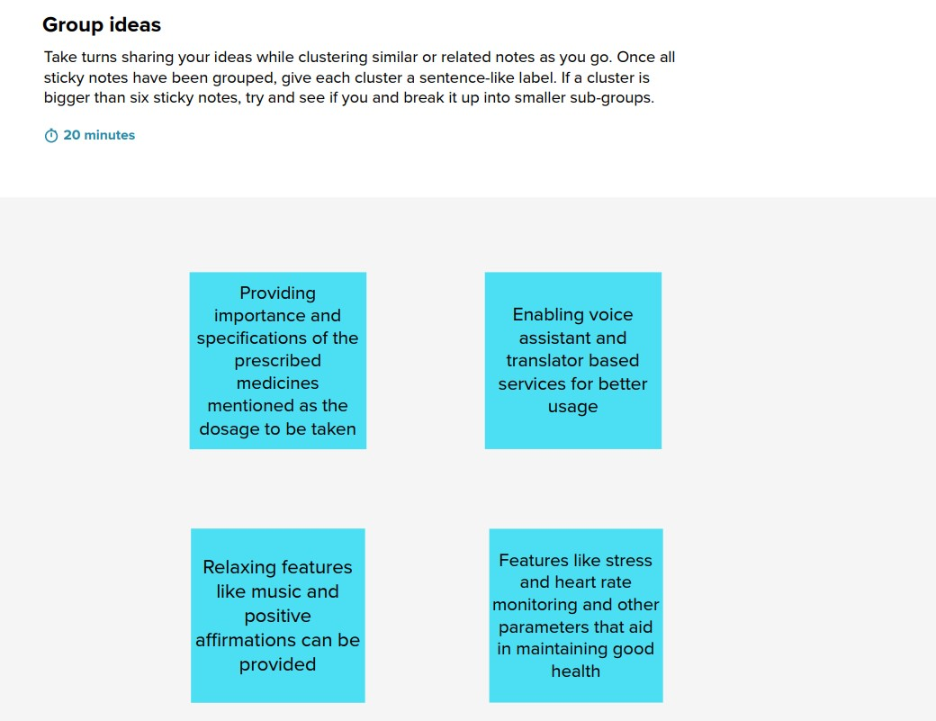

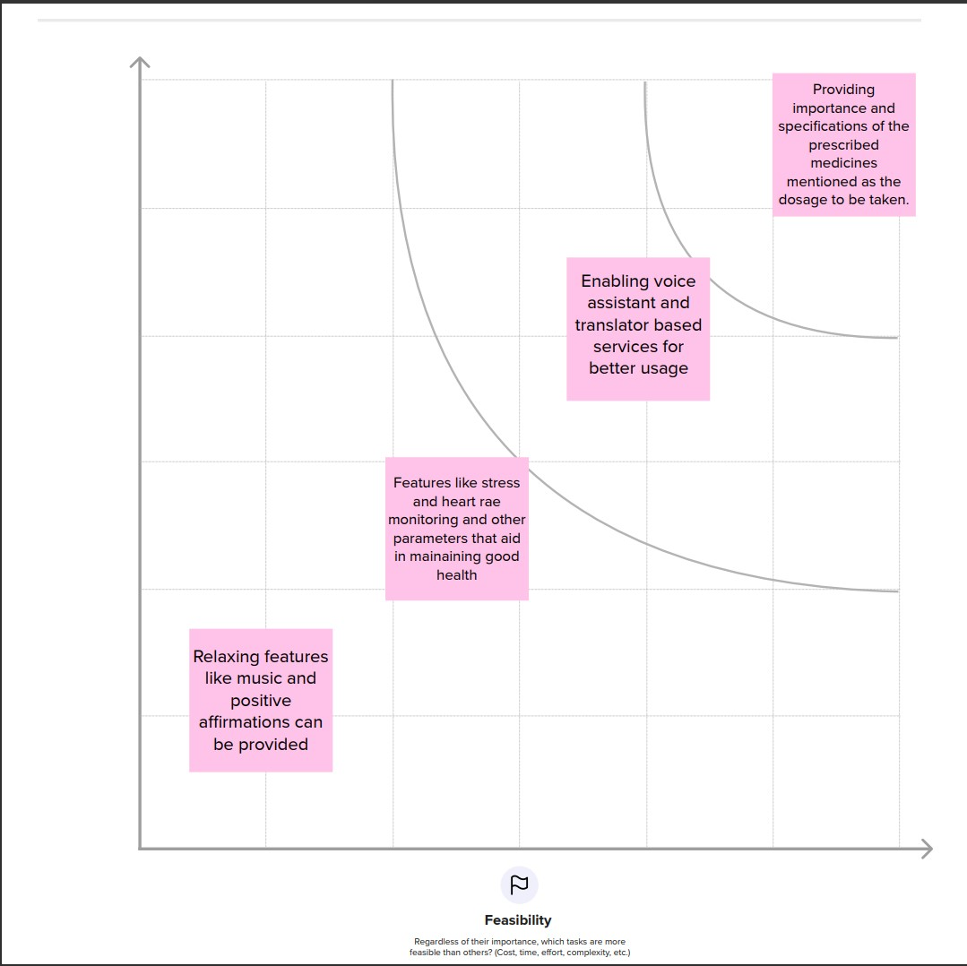

**CHAPTER 4**

**REQUIREMENT ANALYSIS**

## 4.1 REQUIREMENT ANALYSIS

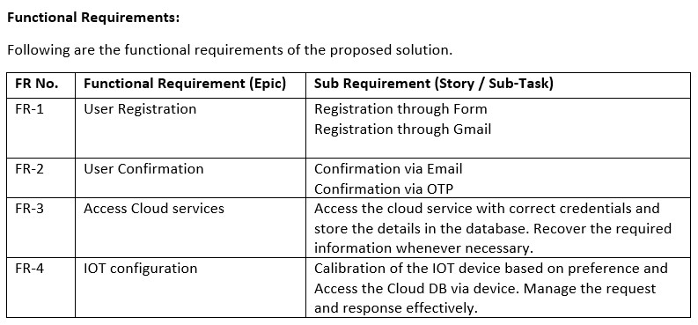

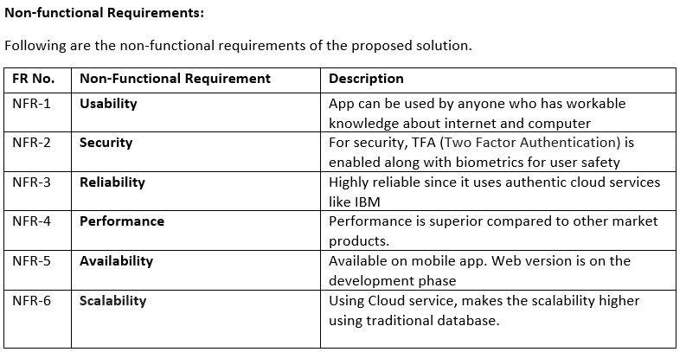

**CHAPTER 5**

# PROJECT DESIGN 5.1 DATA FLOW DIAGRAM

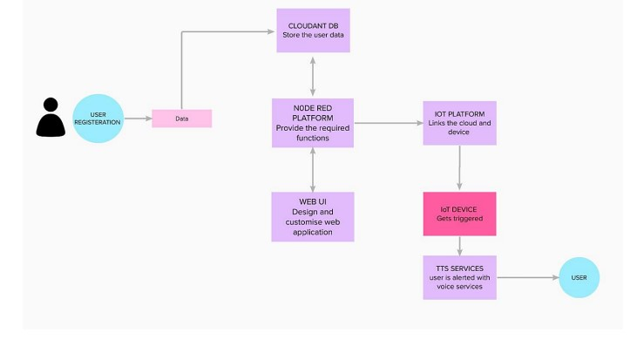

**5.2 SOLUTION AND TECHNICAL ARCHITECTURE**

## 5.3 USER STORIES

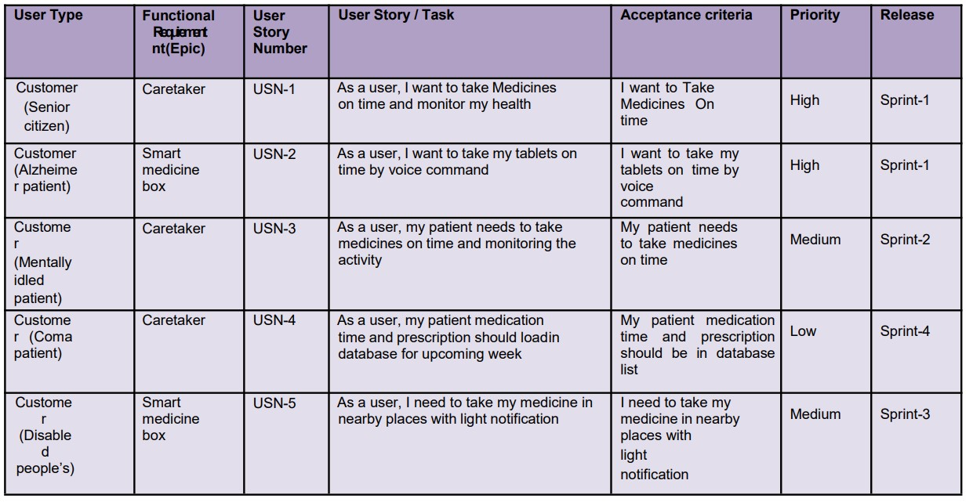

**PROJECT PLANNING AND SCHEDULING**

## 6.1 SPRINT PLANNING AND ESTIMATION

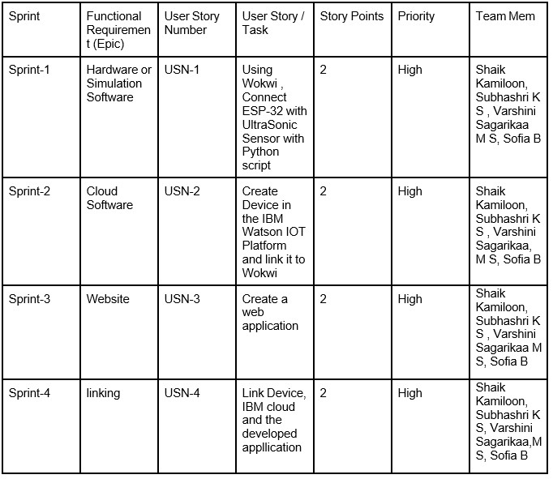

**CODING AND SOLUTIONING**

## 7.1. FEATURE 1

* IoT Device
* IBM Watson platform
* Node - Red
* Cloudant DB
* Web UI
* Python Code
* Wokwi

## 7.2. FEATURE 2

* Login
* MIT Application

## TESTING

After testing the developed code and extensions, the step-by-step observations are listed below.

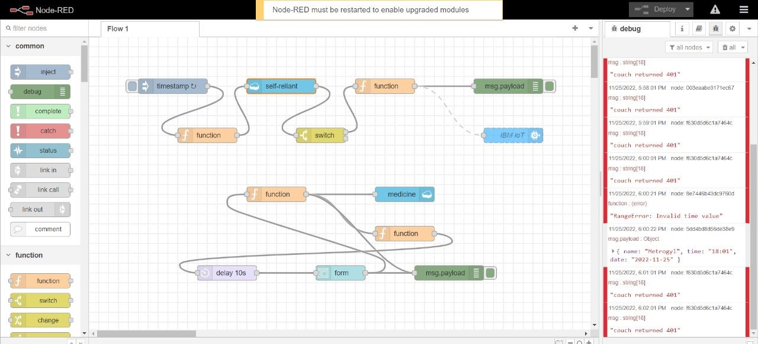

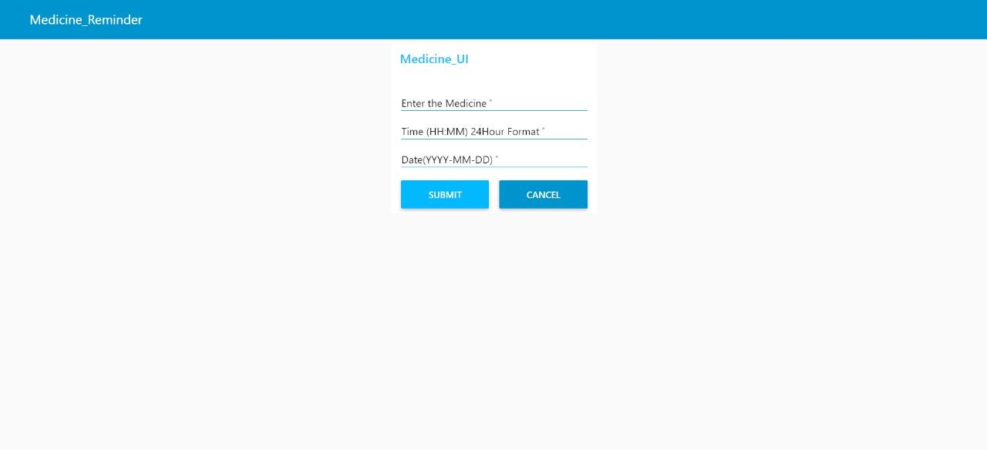

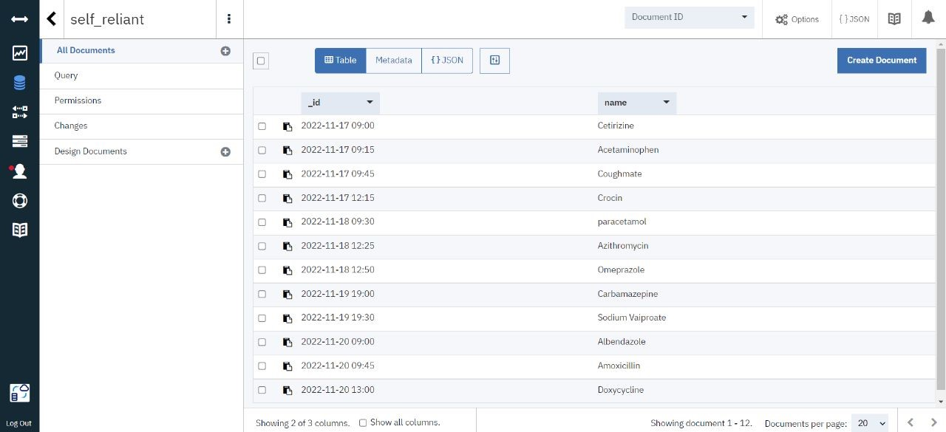

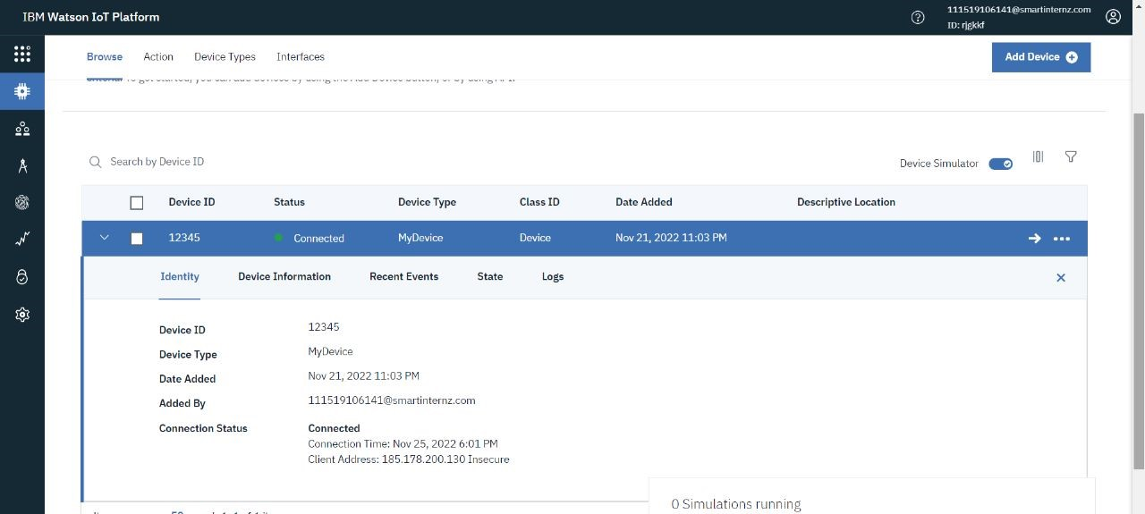

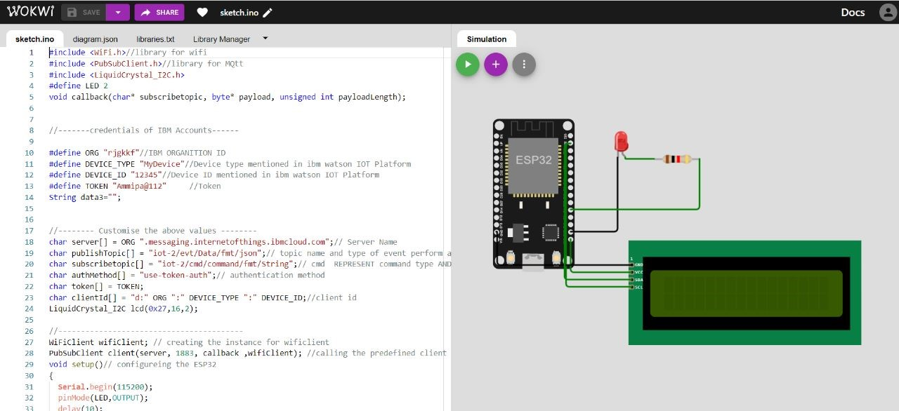

**CHAPTER 9**

**RESULTS**



## CHAPTER 10 ADVANTAGES AND DISADVANTAGES

### 10.1 ADVANTAGES

○ Availability:

One of the primary preferences of possessing a PDA is the capacity to stay in contact with individuals through email, text informing, and telephone. Since PDAs are so convenient and their network so broad, clients can take them anyplace.

○ Association:

Another advantage of possessing a PDA is expanded association.

Scheduleandrundown applications make it simple to monitor arrangements, make notes in a hurry, and document past discussions or other information.

○ Status:

For some PDA clients, the gadget has the additional advantage of meaning a speci c status. The organization gave PDAs might be held for more signi cant level representatives and can come to connote a place of power or signi cance. For individual clients, having the most recent PDA might be an indication of riches or innovative information.

○ Broad Internet Connectivity:

For occupied people, the primary preferred position of getting a PDA is being able to remain associated through email, calls, text informing, and di erent courier applications. These are worked with a broad organization network so clients can get to the Internet anyplace they are.

### 10.2 DISADVANTAGES

○ Cost:

One of the greatest hindrances of a PDA is the expense. Other than paying for the gadget itself, most PDAs require the purchaser to buy into a utilization contract. This includes a month-to-month bill and the chance of overage charges if the client outperforms his designated free telephone minutes or information limits.

○ Interruption:

PDAs may likewise turn into an interruption when they’re not satisfying an authentic need. The capacity to be constantly associated can prompt sitting around riding the Web, settling on telephone decisions, or messing around. Some business clients whine about being“available to come into work” when their colleagues and bosses can reach them whenever.

○ Time constraint:

PDAs are not generally the best response to business arrangements. Paper-based coordinators are a more reasonable choice since PDAs are hard to utilize, information passage is abnormal, they are moderate and beginner clients discover them super uously unpredictable.

○ Restricted in Scope:

PDAs are restricted in degree. They are neither PC substitutions nor would they be able to be successfully used to supplant mobile phones. PDAs are not furnished to manage miniature preparing capacities.

## CHAPTER 11 CONCLUSION

With the progress of science and technology in modern society, the problem of human health care has gradually become an important part of a family. Due to the limitations of the elderly population (such as immobility, memory loss, etc.), there are many problems with medication. Therefore, medication for the elderly needs more attention from society. Drug use accounts for a large proportion of the elderly population, and many products are designed for the elderly. However, many products do not fully conform to the usage habits of the elderly. In today's society, more than 40 percent of the elderly feel lonely. The data show that the happiness of the elderly is largely due to the support and encouragement from their families. The relationship between the elderly and their adult children has also become an important social issue. Many times not taking the medicines on time leads to death or severe issues. So to avoid such situations this application will be very helpful.

## CHAPTER 12 FUTURE SCOPE

I believe that in the future, we will have many reasons to care about and for the elderly community because this is not only a moral thing but also a prerequisite for the continuation of the development of the world. We need to pay enough attention to this group, and I believe that the medicine reminder application will be of great use to elderly people as they can be independent and live happily and healthily.

An application can also be developed so that it can be interfaced with the IoT device such as a smartwatch, which can further assist in solving the purpose.

A sample application developed using the MIT App Inventor is mentioned.

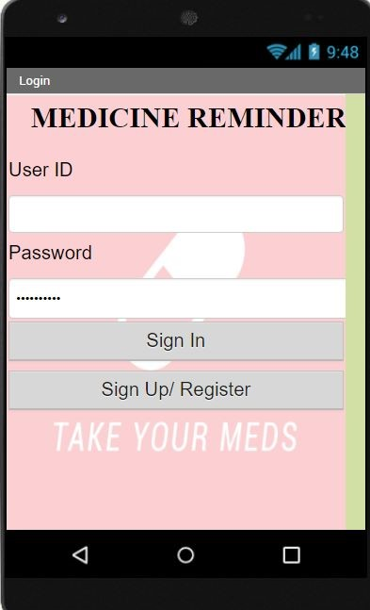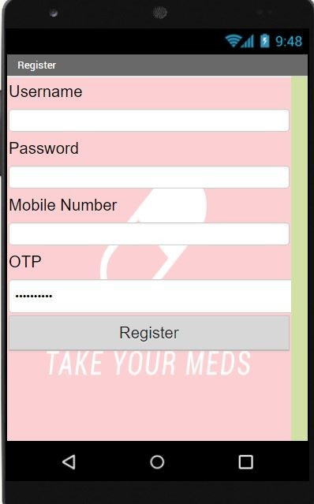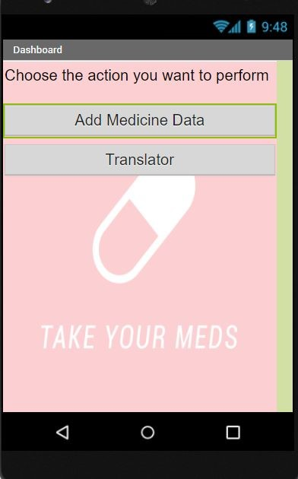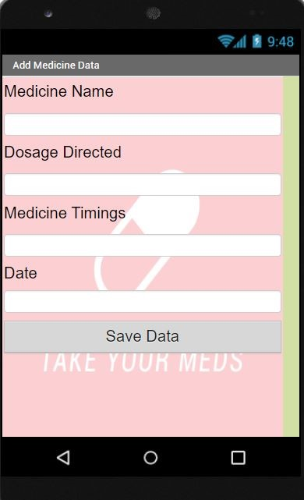

## CHAPTER 13 APPENDIX

### 13.1 SOURCE CODE WOKWI SIMULATED CODE

#include <WiFi.h>//library for wifi

#include <PubSubClient.h>//library for MQtt

#include <LiquidCrystal_I2C.h>

#define LED 2 void callback(char* subscribetopic, byte* payload, unsigned int payloadLength);

//-------credentials of IBM Accounts------

#define ORG "rjgkkf"//IBM ORGANITION ID

#define DEVICE_TYPE "MyDevice"//Device type mentioned in ibm watson IOT Platform

#define DEVICE_ID "12345"//Device ID mentioned in ibm watson IOT Platform

#define TOKEN "Ammipa@112" //Token

String data3="";

//-------- Customise the above values -------char server[] = ORG ".messaging.internetofthings.ibmcloud.com";// Server Name

char publishTopic[] = "iot-2/evt/Data/fmt/json";// topic name and type of event perform and format in which data to be send

char subscribetopic[] = "iot-2/cmd/command/fmt/String";// cmd REPRESENT command type AND COMMAND IS TEST OF FORMAT STRING char authMethod[] = "use-token-auth";// authentication method char token[] = TOKEN; char clientId[] = "d:" ORG ":" DEVICE_TYPE ":" DEVICE_ID;//client id

LiquidCrystal_I2C lcd(0x27,16,2);

//-----------------------------------------

WiFiClient wifiClient; // creating the instance for wificlient

PubSubClient client(server, 1883, callback ,wifiClient); //calling the predefined client id by passing parameter like server id,portand wificredential void setup()// configureing the ESP32

{ **Serial**.begin(115200); pinMode(LED,OUTPUT); delay(10); **Serial**.println(); wificonnect(); mqttconnect();

}

void loop()// Recursive Function

{ if (!client.loop()) { mqttconnect();

}

}

/*.....................................retrieving to Cloud...............................*/ void mqttconnect() { if (!client.connected()) {

**Serial**.print("Reconnecting client to "); **Serial**.println(server); while (!!!client.connect(clientId, authMethod, token)) {

**Serial**.print(".");

delay(500);

}

initManagedDevice(); **Serial**.println();

} } void wificonnect() //function defination for wificonnect

{

**Serial**.println();

**Serial**.print("Connecting to ");

WiFi.begin("Wokwi-GUEST", "", 6);//passing the wifi credentials to establish the connection while (WiFi.status() != WL_CONNECTED) { delay(500); **Serial**.print(".");

}

**Serial**.println("");

**Serial**.println("WiFi connected");

**Serial**.println("IP address: ");

**Serial**.println(WiFi.localIP()); }

void initManagedDevice() { if (client.subscribe(subscribetopic)) {

**Serial**.println((subscribetopic));

**Serial**.println("subscribe to cmd OK");

} else {

**Serial**.println("subscribe to cmd FAILED");

}

}

void callback(char* subscribetopic, byte* payload, unsigned int payloadLength) {

**Serial**.print("callback invoked for topic: "); **Serial**.println(subscribetopic); for (int i = 0; i < payloadLength; i++) { //Serial.print((char)payload[i]); data3 += (char)payload[i];

}

**Serial**.println("Please take "+ data3); if(data3 != "")

{ lcd.init(); lcd.print("Take"+ data3);

digitalWrite(LED,HIGH); delay(20000); digitalWrite(LED,LOW);

}

else { digitalWrite(LED,LOW);

} data3="";

}